Now we are going to learn about how to make class components and how to use them by the whether it is react js or react native we use functional component there but still you should know about class component Why

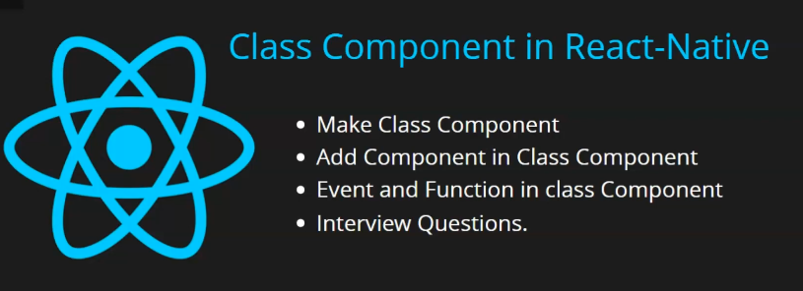

Because in office some product come which was developed seven years ago Now you need to work on it and in that react native old version was used class component was used then how will you deal with this because it is not necessary that you will be called to make the website from scratch you might be called to work on already made application but if there is class component then to deal with that you need to know about class component but in this series we will make two lesson one is you are currently using and then comes we will know how to handle props and state there

In this lesson we are going to make a class component

And then we will add component to the class component like Text, Button, InputBox etc and then we make class component and then we will use it in another class component there is no major difference there and then we will know how ewe can fire event and we can call function inside class component and at last we will discuss some interview question.

We remove the functional component from our App.jsx

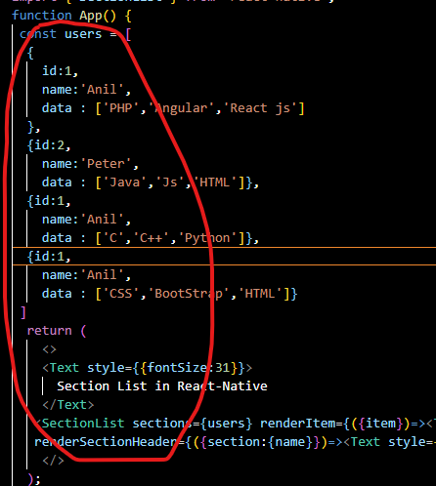

Now to make class component we will type class

If you have worked in OOPs then you will understand by looking at and if you have not studies OOP language like Java, C++ don’t worry you will understand it

After class name type the name of the class that is App

And also extend a class or inherit a class that React.component or you can import Render(default export) and Component( not default ) and then app inherit this by component this is the story of class component . In functional component we don’t use inheritance

And now comes render which is a method inside the class component inside which we will return our jsx we don’t return directly because inside class you need method to return something in functional you return anything and then inside render you can return jsx we take a view and then inside we write Text Component that shows the text Class Component apply styles over it the concept styles are all same.

Code below

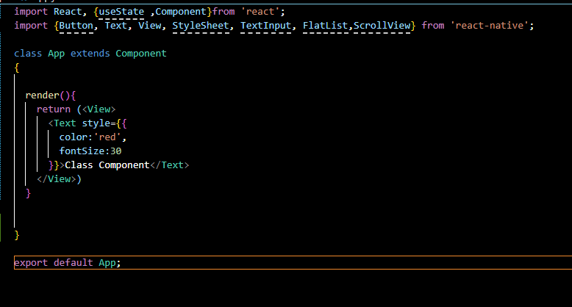

Output is given below



And no suppose you want to use another component that is Button It is all same like you did before

The return part will be same it is just difference is in declaration between class and function

Now next thing if we have custom class component then how we could use it to make that we make another component In our component folder

You can name it all you want

And then paste the App code in Student

Just change the name so that we don’t have to write a lot Now in export default we export Student

Inside render you just need to write text component and in between type Student Component. Yu can use it in App.jsx

Now import Student in App.jsx like we did in functional and use it also like functionl by putting the Students component in jsx.

As shown below

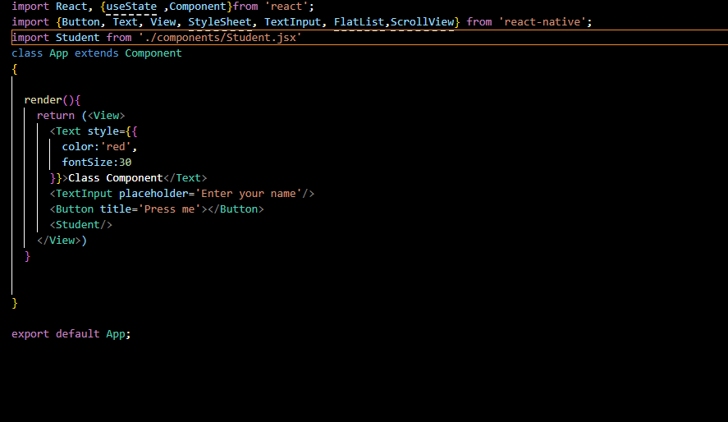

Output

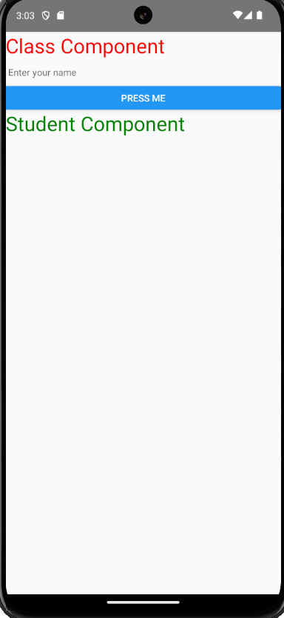

Now last thing suppose you want to call a function on the basis of click

For now teacher will not tell us about state it will be told in next lesson

For now just assume you have a function

**Note:-**

You cannot use const or let keyword

Now we write a function fruit inside class and then inside it do console.warn and print “Apple”

Now we do the same which we did in functional that is pass onPress props and then pass the function that will be called when the button will be clicked now we will use this keyword to tell that the passed function fruit belongs to the same class Student Now when we click on the button we will get the warning which you can see fully in your debugger So by this you can make event

In interview question you could be asked that we use functional component or class component

You can that we can use class component but nowadays functional component is recommended.

6:55

In react native official documentation

They can ask difference between class component and functional component

Teacher will not tell the answer you need to answer this yourself.

Teacher will dedicate a separate lesson for it.

Third is how we can call a function you can see it like we did in our example

Now they may ask what is render function and you can say it is used in class component

Whatever UI part we need to return we return it by render method see user can see it

Because inside the class you cannot directly return because class is not made to return something

In function we can return things but inside you cannot return anything what reactjs did is create a render function and whatever we return we see it as an output of the class

See you in the next lesson